MODULE 1 – ARRAY (CORE LINEAR DATA STRUCTURE)

1. What is an Array
- An array is a linear data structure
- Stores homogeneous data
- Stored in contiguous memory
- Accessed using index
- Size is fixed
Meaning
Array gives fast access using index but poor flexibility in size.

2. Array Memory Representation (VERY IMPORTANT)
int[] arr = new int[5];
Memory layout:
Index → 0 1 2 3 4
Value → [ ] [ ] [ ] [ ] [ ]
- Continuous memory
- Address calculation:
address = base + index * size
Interview line
Arrays support O(1) random access due to contiguous memory.

3. Types of Arrays

A. Static Array
int[] arr = new int[5];
- Fixed size
- Cannot grow or shrink

B. Dynamic Array (Logical Concept)
Java does NOT support true dynamic arrays without collections.
We manually create a new array and copy elements.

4. Basic Array Operations

4.1 Traversal
Definition
- Access each element once
Code
void traverse(int[] arr) {
for (int i = 0; i < arr.length; i++) {
System.out.print(arr[i] + " ");
}
}
Time Complexity
- O(n)

4.2 Insertion
Insert at End
int[] insertAtEnd(int[] arr, int value) {
int[] newArr = new int[arr.length + 1];

for (int i = 0; i < arr.length; i++) {
newArr[i] = arr[i];
}

newArr[arr.length] = value;
return newArr;
}
- Time → O(n)
- Space → O(n)

Insert at Position
int[] insertAtPos(int[] arr, int pos, int value) {
int[] newArr = new int[arr.length + 1];

for (int i = 0; i < pos; i++) {
newArr[i] = arr[i];
}

newArr[pos] = value;

for (int i = pos; i < arr.length; i++) {
newArr[i + 1] = arr[i];
}

return newArr;
}

4.3 Deletion
Delete by Index
int[] deleteAtPos(int[] arr, int pos) {
int[] newArr = new int[arr.length - 1];

for (int i = 0; i < pos; i++) {
newArr[i] = arr[i];
}

for (int i = pos + 1; i < arr.length; i++) {
newArr[i - 1] = arr[i];
}

return newArr;
}

4.4 Update
void update(int[] arr, int index, int value) {
arr[index] = value;
}
- Time → O(1)

4.5 Searching

Linear Search
int linearSearch(int[] arr, int key) {
for (int i = 0; i < arr.length; i++) {
if (arr[i] == key) return i;
}
return -1;
}
- Time → O(n)

Binary Search (Array Must Be Sorted)
int binarySearch(int[] arr, int key) {
int low = 0, high = arr.length - 1;

while (low <= high) {
int mid = (low + high) / 2;

if (arr[mid] == key) return mid;
else if (arr[mid] < key) low = mid + 1;
else high = mid - 1;
}
return -1;
}
- Time → O(log n)

5. 1D Array Problems (IMPORTANT)

Reverse Array
void reverse(int[] arr) {
int left = 0, right = arr.length - 1;

while (left < right) {
int temp = arr[left];
arr[left] = arr[right];
arr[right] = temp;

left++;
right--;
}
}

Find Max & Min
int findMax(int[] arr) {
int max = arr[0];
for (int i = 1; i < arr.length; i++) {
if (arr[i] > max) max = arr[i];
}
return max;
}

Second Largest Element
int secondLargest(int[] arr) {
int max = Integer.MIN_VALUE;
int second = Integer.MIN_VALUE;

for (int x : arr) {
if (x > max) {
second = max;
max = x;
} else if (x > second && x != max) {
second = x;
}
}
return second;
}

6. 2D Array (Matrix)

Definition
- Array of arrays
- Used for:
  - Matrix
  - Tables
  - Board problems

Declaration
int[][] matrix = new int[2][3];

Traversal
void traverse2D(int[][] mat) {
for (int i = 0; i < mat.length; i++) {
for (int j = 0; j < mat[i].length; j++) {
System.out.print(mat[i][j] + " ");
}
System.out.println();
}
}

Matrix Addition
int[][] add(int[][] a, int[][] b) {
int[][] result = new int[a.length][a[0].length];

for (int i = 0; i < a.length; i++) {
for (int j = 0; j < a[0].length; j++) {
result[i][j] = a[i][j] + b[i][j];
}
}
return result;
}

7. Array Rotation (Interview Favorite)

Rotate Right by K
void rotateRight(int[] arr, int k) {
k = k % arr.length;
reversePart(arr, 0, arr.length - 1);
reversePart(arr, 0, k - 1);
reversePart(arr, k, arr.length - 1);
}

void reversePart(int[] arr, int l, int r) {
while (l < r) {
int t = arr[l];
arr[l++] = arr[r];
arr[r--] = t;
}
}

8. Time & Space Complexity Summary
- Access → O(1)
- Search → O(n)
- Insert/Delete → O(n)
- Binary Search → O(log n)
- Space → Continuous memory

9. Advantages of Array
- Fast access
- Simple structure
- Cache friendly

10. Limitations of Array
- Fixed size
- Costly insertion & deletion
- Memory wastage or overflow

11. Real-Time Use Cases
- Static data
- Image pixels
- Matrix operations
- Low-level systems

12. Common Interview Questions
- Why array index access is O(1)?
- Why insertion is costly?
- Array vs Linked List?
- When to use array?
- Binary search prerequisites?

ONE-LINE INTERVIEW SUMMARY
Array is a linear data structure that stores homogeneous elements in contiguous memory, offering fast access but costly insertion and deletion.
Below is MODULE 2 – STRING (DSA DEEP DIVE) implemented in pure Java,
NO Collection Framework, NO StringBuilder shortcuts for logic,
everything done using character arrays and basic loops, step-by-step.

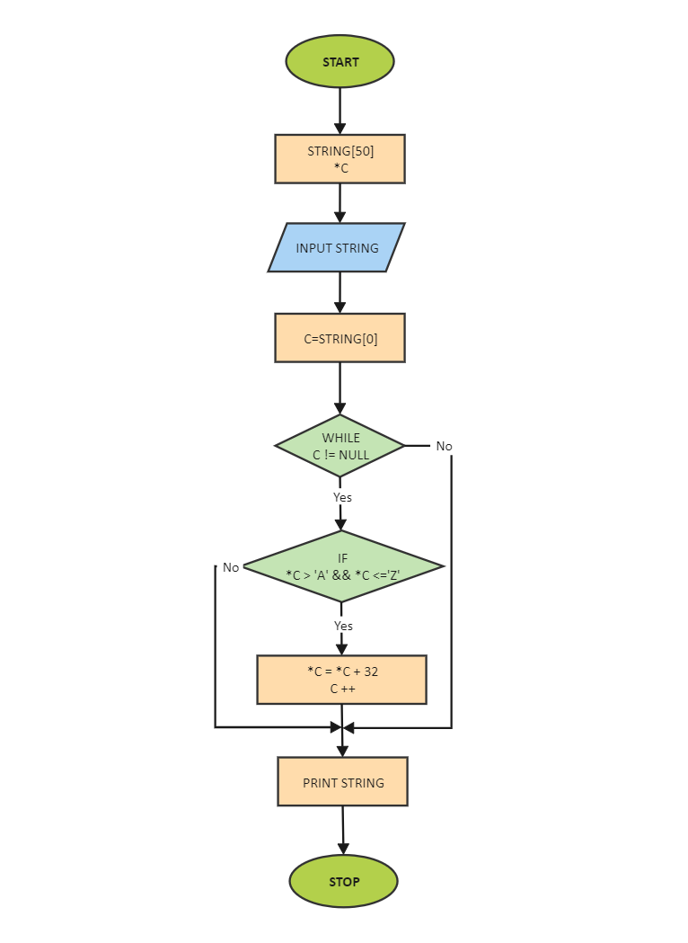

MODULE 2 – STRING (CHARACTER ARRAY BASED DSA)

1. What is a String in DSA Context
- In DSA, a string is treated as a character array
- Each character occupies contiguous memory
- Indexed access like array
char[] str = {'J','A','V','A'};
Meaning
String problems are solved by array traversal + logic, not library methods.

2. String Memory Representation
char[] str = {'H','E','L','L','O'};
Memory:
Index → 0 1 2 3 4
Value → 'H' 'E' 'L' 'L' 'O'
- Continuous memory
- Access time → O(1)

3. Why We Avoid String Methods in DSA
Not allowed:
- String.reverse()
- contains()
- split()
- replace()
Allowed:
- charAt() (conceptually same as array access)
- Manual loops

4. Basic String Operations (Core)

4.1 Find Length of String
Without using length()
int length(char[] str) {
int count = 0;
for (char c : str) {
count++;
}
return count;
}
- Time → O(n)
- Space → O(1)

4.2 Traverse String
void traverse(char[] str) {
for (int i = 0; i < str.length; i++) {
System.out.print(str[i]);
}
}

5. Reverse a String (VERY IMPORTANT)

Method 1: Two Pointer Technique
void reverse(char[] str) {
int left = 0;
int right = str.length - 1;

while (left < right) {
char temp = str[left];
str[left] = str[right];
str[right] = temp;

left++;
right--;
}
}
- Time → O(n)
- Space → O(1)
- Interview favorite

6. Palindrome Check
Definition
- String reads same forward & backward

boolean isPalindrome(char[] str) {
int left = 0;
int right = str.length - 1;

while (left < right) {
if (str[left] != str[right]) {
return false;
}
left++;
right--;
}
return true;
}
Examples:
- MADAM → true
- JAVA → false

7. Count Frequency of Characters
(Assume lowercase a–z)

void frequency(char[] str) {
int[] freq = new int[26];

for (char c : str) {
freq[c - 'a']++;
}

for (int i = 0; i < 26; i++) {
if (freq[i] > 0) {
System.out.println((char)(i + 'a') + " -> " + freq[i]);
}
}
}
- Uses array, not Map
- Interview standard

8. Find Duplicate Characters
void duplicates(char[] str) {
int[] freq = new int[256];

for (char c : str) {
freq[c]++;
}

for (int i = 0; i < 256; i++) {
if (freq[i] > 1) {
System.out.println((char)i + " repeated " + freq[i] + " times");
}
}
}

9. Anagram Check (VERY IMPORTANT)
Definition
Two strings contain same characters in same frequency.

boolean isAnagram(char[] a, char[] b) {
if (a.length != b.length) return false;

int[] freq = new int[256];

for (char c : a) freq[c]++;
for (char c : b) freq[c]--;

for (int i = 0; i < 256; i++) {
if (freq[i] != 0) return false;
}
return true;
}
Examples:
- listen & silent → true
- java & ajav → true

10. Count Vowels & Consonants
void countVowels(char[] str) {
int vowels = 0, consonants = 0;

for (char c : str) {
if (c=='a'||c=='e'||c=='i'||c=='o'||c=='u') {
vowels++;
} else if (c >= 'a' && c <= 'z') {
consonants++;
}
}

System.out.println("Vowels: " + vowels);
System.out.println("Consonants: " + consonants);
}

11. Remove Spaces from String
char[] removeSpaces(char[] str) {
char[] result = new char[str.length];
int index = 0;

for (char c : str) {
if (c != ' ') {
result[index++] = c;
}
}
return result;
}

12. String Rotation Check
Logic
- ABCD rotated → CDAB

boolean isRotation(String s1, String s2) {
if (s1.length() != s2.length()) return false;

String combined = s1 + s1;
return contains(combined.toCharArray(), s2.toCharArray());
}

boolean contains(char[] text, char[] pattern) {
for (int i = 0; i <= text.length - pattern.length; i++) {
int j = 0;
while (j < pattern.length && text[i + j] == pattern[j]) {
j++;
}
if (j == pattern.length) return true;
}
return false;
}

13. Longest Word in a Sentence
int longestWord(char[] str) {
int max = 0, count = 0;

for (char c : str) {
if (c != ' ') {
count++;
max = Math.max(max, count);
} else {
count = 0;
}
}
return max;
}

14. Time & Space Complexity Summary
- Traversal → O(n)
- Reverse → O(n)
- Palindrome → O(n)
- Frequency → O(n)
- Anagram → O(n)
- Extra space → O(1) or O(256)

15. String Interview Patterns
- Two pointer
- Frequency array
- Sliding window (later)
- Pattern matching

16. Advantages of Character Array Approach
- Full control
- Interview-friendly
- Language independent
- Efficient

17. Common Interview Questions
- Why char array preferred in DSA?
- How to check palindrome?
- Anagram logic?
- Remove duplicates?
- Reverse without extra space?

ONE-LINE INTERVIEW SUMMARY
In DSA, strings are treated as character arrays and solved using traversal, two-pointer techniques, and frequency counting without relying on built-in libraries.

